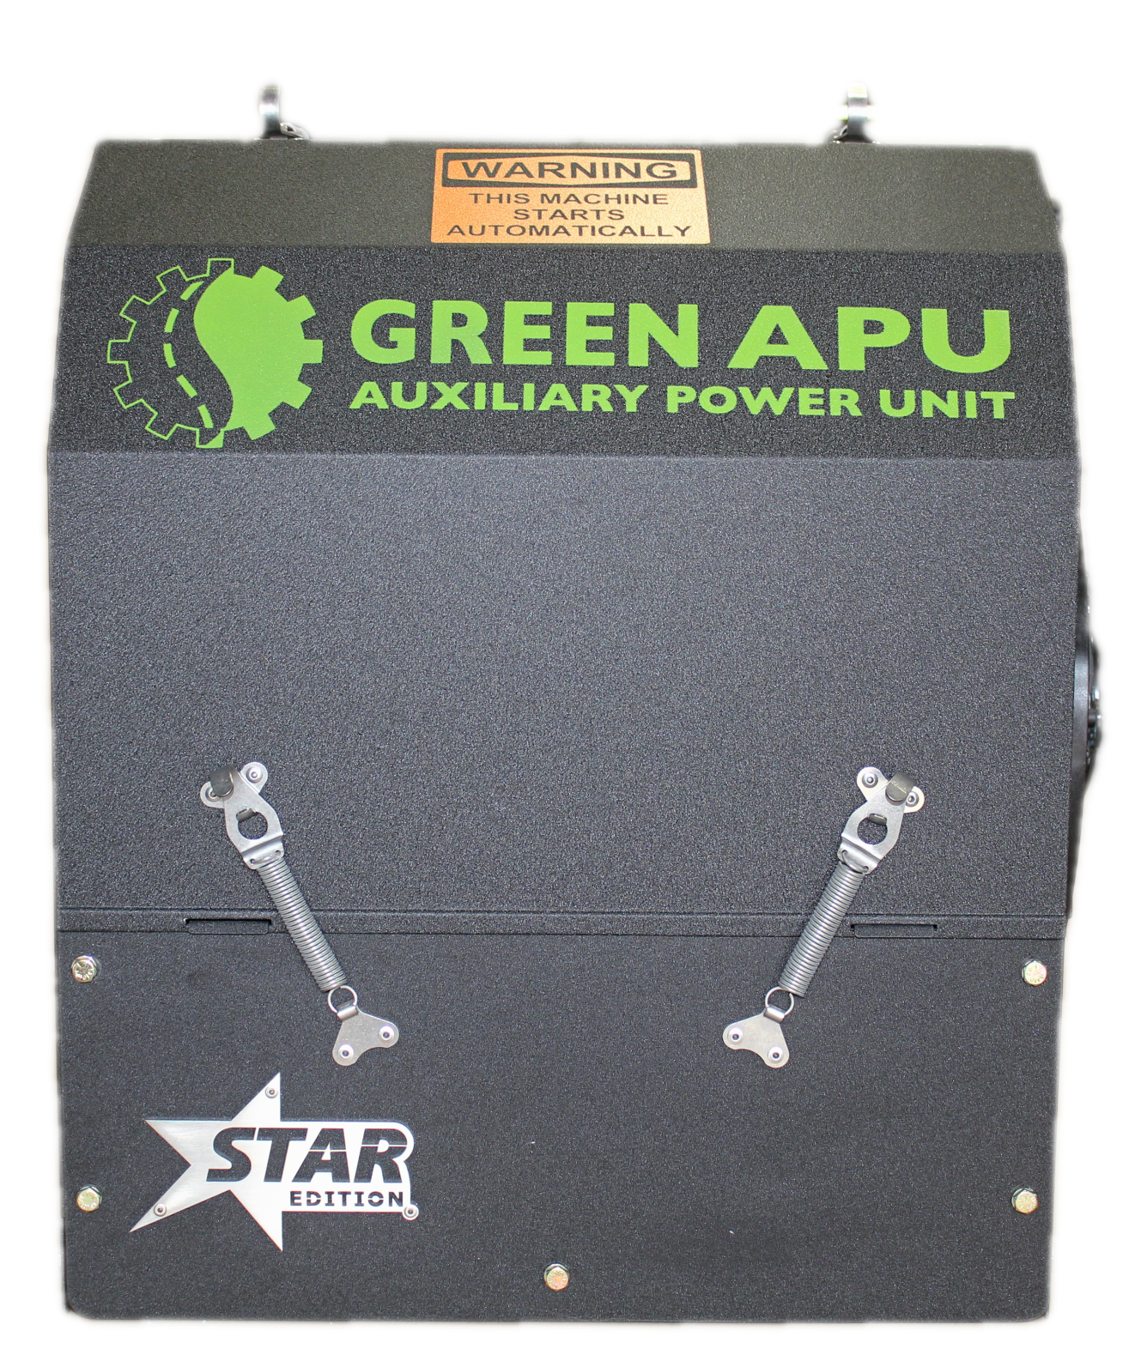

Operations Manual

&

Reference Guide

Disclaimer

This document is published for informational purposes only. Green APU, LLC makes no representations or warranties, express or implied, with respect to the information, recommendations and descriptions contained in this manual and such information, recommendations and descriptions should not be regarded as all-inclusive or covering all contingencies. In the event you have any questions or require further information, please contact your local Green APU Technical Support at 877-751-0606, Option 3.

The procedures described herein should only be undertaken by suitably qualified personnel. Failure to implement these procedures correctly may cause damage to the Green APU unit or other property or personal injury.

Green APU, LLC and its affiliates shall have no liability in contract or tort (including negligence and/or strict liability) or otherwise, to any person or entity for any personal injury, property damage or any other direct, indirect, special or consequential damage or liability whatsoever, arising out of or resulting from any actions by any person that are contrary to this manual or any of the information, recommendations or descriptions contained herein.

Always ensure unit is completely off and disconnected from power prior to servicing.
IMPORTANT

Your GREEN APU includes
LIFETIME
24/7 Technical Support

If you experience any issues with the performance of your APU,

Please Call

877-751-0686
Option 3

It is important to call Technical Support WHILE the issue is occurring.

This ensures the timeliest resolution and the most effective troubleshooting.

WEIGHT EXEMPTION CERTIFICATION

July 1, 2012, Vehicle Weight Exemption Certification

Green APU LLC certified as follow:

Auxiliary power unit GREEN APU installed weighs is 530 pounds.

Section 127(a) was amended to add item 12 that States the following:

(12) HEAVY DUTY VEHICLES-

(A) IN GENERAL- Subject to subparagraphs (B) and (C), in order to promote reduction of fuel use and
emissions because of engine idling, the maximum gross vehicle weight limit and the axle weight limit
for any heavy-duty vehicle equipped with an idle reduction technology shall be increased by a quantity
necessary to compensate for the additional weight of the idle reduction system.
(B) MAXIMUM WEIGHT INCREASE- The weight increase under subparagraph (A) shall be not greater
than 400 pounds.
(C) PROOF- On request by a regulatory agency or law enforcement agency, the vehicle operator shall
provide proof (through demonstration or certification) that--
(i) the idle reduction technology is fully functional at all times; and
(ii) the 400-pound gross weight increase is not used for any purpose other than the use of idle
reduction technology described in subparagraph (A).

Update:

On June 6, 2012 President Barack Obama signed the Federal Highway Bill. As part of the bill the
following updates were made in reference to idle reduction technologies to include APU’s.

SEC. 1510. IDLE REDUCTION TECHNOLOGY.
Section 127(a)(12) of title 23, United States Code, is amended—
(1) in subparagraph (B), by striking ‘‘400’’ and inserting ‘‘550’’; and
(2) in subparagraph (C)(ii), by striking ‘‘400-pound’’ and inserting ‘‘550-pound’’.
As a result of these changes the new federal weight exemption has been increased from 400 pounds
to 550 pounds for an APU.

Best Regards,
Irek Panek
Direct 630 465 2602
Product Developer

TABLE OF CONTENTS

- System Overview…………..1

- Controller Navigation…….2

- Climate Control Mode……3

- Battery Charge Mode…….4

- Maintenance………………….5,6,7

- Service and Support…….…8

- Parts………………………..….…9

- Additional Info……………...10

SYSTEM OVERVIEW

Your Green APU performs two primary functions:

CLIMATE CONTROL
Climate control mode maintains in cab comfort.
The unit will alternate
between AC and heat in
accordance to the set temperature.

BATTERY MONITORING /
ENGINE PREHEAT
For use when parking the truck unattended
for any extended length of time.

System will turn on unit when:

Battery Voltage drops below 12.6 volts
Or
Coolant Temp drops below 32 degrees

IMPORTANT:
Battery Monitoring must be
MANUALLY ACTIVATED
each time you wish to use it.
CONTROLLER NAVIGATION

Your Green APU was designed with simplicity and ease of use in mind.

A single knob controls provides access to all features by rotating and clicking.

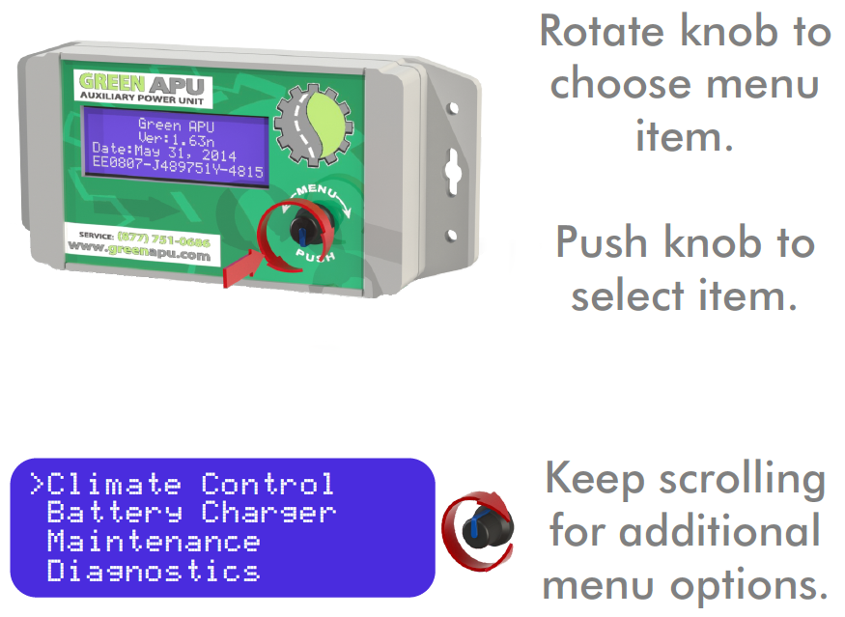

CLIMATE CONTROL

Heat, AC, and Cab Power

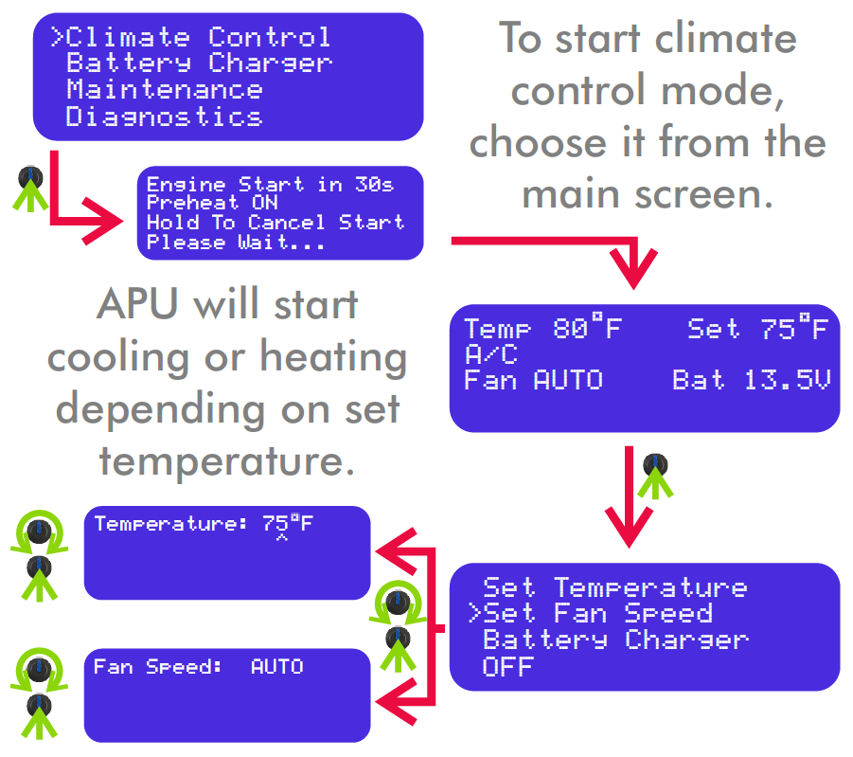

For optimal performance, the recommend fan speed is
AUTO

BATTERY MONITORING
ENGINE PREHEAT

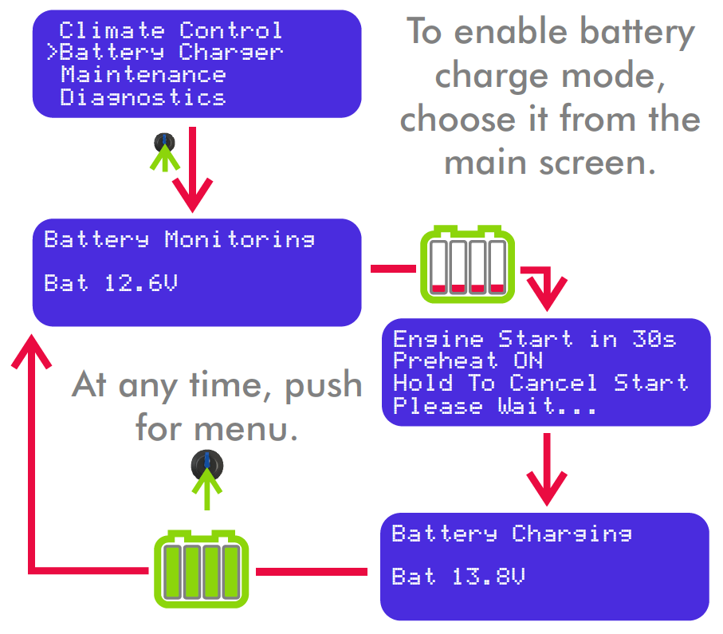

IMPORTANT:
Battery Monitoring must be
MANUALLY ACTIVATED
each time you wish to use it.
MAINTENANCE

Each Green APU requires PM Service every 1000 Hours (Star Edition)
- Or --
600 Hours (all previous generations)

PM Service consists of:

- Oil Change (10w-30 or 15w-40)
- Oil, Fuel and Air Filter Replacement
- Belt Inspection / Replacement
- Cabin Filter Cleaning
- Overall Inspection

Belts should be replaced at the first sign
of wear or every other PM Service

The cabin filter is located within the cab under the bed.

A notification message will display upon startup
when your unit is approaching the PM Service.

The unit may no longer start once the
PM Hour Limit has been reached.

MAINTENANCE

Basic Maintenance Parts List

KUBOTA Units
(S/N’s beginning in KB and KS)

FILTERS | BELTS
Oil: WIX 51344  Fuel: WIX 33390  Air: WIX 49913  Oil Capacity  4.25 Quarts | STAR Edition (Serpentine)  K60625  K60625HD (preferred)  Dual Belts  Compressor Alternator  Bando Continental  6PK775 15371

PERKINS and CAT Units

FILTERS | BELTS
Oil: WIX 163  Fuel: WIX 33262  Air: K&N RU-0160  Oil Capacity  2.8 Quarts | Compressor:  Bando 6PK775  Alternator  Bando RPF2310

Always ensure unit is completely off and disconnected from power prior to servicing.
Viewing Service Hours

To View your current service hours, select
Maintenance > Service Hours

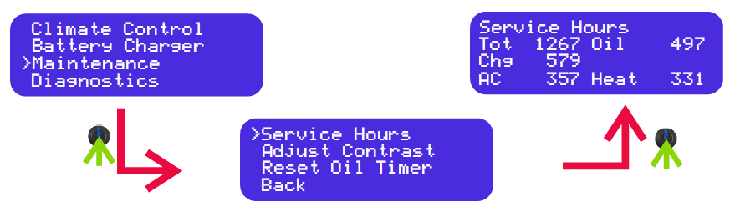

Resetting Service Hours

Once Service is complete you must reset the oil timer.
To reset the oil timer, select
Maintenance > Reset Oil Timer

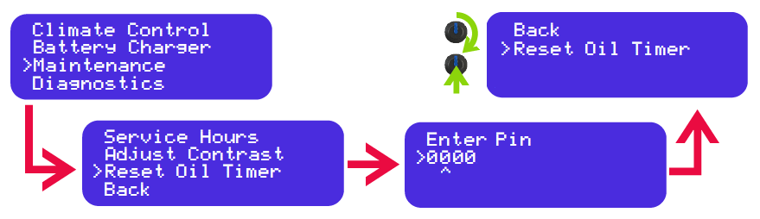

A pin may be required to complete the reset.

The pin can be obtained from the owner and can be optionally recorded here: ____________ | Once the code is entered, navigate to “Reset Oil Timer”. Click to reset hours.

The Oil Timer will now be reset to zero.
This can be confirmed by viewing the service hours
as described above.
SERVICE

Green APU’s
Factory Repair Shop is located at:
13067 Main Street
Lemont, IL 60439

HOURS OF OPERATION

Monday – Friday  8AM – 6 PM | Saturday  8AM – 12PM  Appointment Only

The Factory Repair Shop can be reached at
877-751-0686
Option 4

A map of Green APU Distributors and
Affiliated Service Locations can be found online at:
greenapu.com/locations

PARTS

Detailed Parts Listing
All Green APU Models

PART | KUBOTA | PERKINS/CAT | YANMAR
OIL FILTER | WIX 51344 | WIX 163 | WIX 51358
FUEL FILTER | WIX 33390 | WIX 33262 | WIX 33390
AIR FILTER | WIX 49913 /  MANN C1140 | K&N RU-0160 | WIX 49913 /  MANN C1141
SERPENTINE BELT  (STAR EDITION) | K60625  K60625HD (preferred)
COMPRESSOR BELT | Bando 6PK775 | Bando 6PK775 | Bando 6PK775
ALTERNATOR BELT | Continental 15371 | Bando RPF2310 | Bando RPF3360
COMPRESSOR | Sanden 4711 SD7H15 | Sanden 4711 SD7H15 | Sanden 4711 SD7H15
DRYER | 74R2546 | 74R2546 | 74R2546
CONDENSER | 4730TY | 4730TY | 4730TY
CONDENSER FAN | 30101510 SPAL | 30101510 SPAL | 30101510 SPAL
REAR SEAL | 1G460-04460 | 198636080 | 119734-02220
FRONT SEAL | 1J094-04140 | 198636090 | 119717-01800
GLOW PLUGS | 1G679-65512 | NGK YE01 | 119717-77801
OIL P SENSOR | 15841-39013 | U85246210 | 114250-39450
OH SWITCH | 51601-37670 | 385720500 | 121250-44901
TEMP SENSOR | 39220-21330 | 39220-21330 | 39220-21330
FUSE BOX TERMINAL | 12176388 | 12176388 | 12176388
SMALL RELAY | 303-1AH-C-R1-U1 | 303-1AH-C-R1-U1 | 303-1AH-C-R1-U1
BIG RELAY | PC785-1A-12S-R-X | PC785-1A-12S-R-X | PC785-1A-12S-R-X
EXPANSION VALVE | 71R8321 | 71R8321(Big) 71R8300(Small) | 71R8321
ACTUATOR MOTOR | RD-5-12450-1 | RD-5-12450-1 | RD-5-12450-1
BINARY SWITCH(AC) | 71R7075 | 71R7075 | 71R7075

To Order Parts
Call Green APU’s Parts Line at:
877-751-0686
Option 2
ADDITIONAL INFO

COOLANT
Your Green APU is connected to your trucks coolant system.
This allows the APU to perform its engine preheat functions.

Avoid Excessive Heat Transfer Upon Startup
Today’s modern trucks often run at high operating temperatures, particularly in extreme environments.

It is recommended that you allow your truck to idle for at least 5 mins before shutting down while initially using your APU. This will allow the system to cool and prevent excessive heat transfer to the APU.

Utilize Shut-Off Valves If Necessary
As your truck and APU coolant systems are connected, a coolant leak in the APU has the potential to drain coolant from the trucks main engine.

Green APU installations preformed after June 2019 are equipped with manual shut-off valves. In the event of a coolant leak within your APU system, closing both valves will allow the truck to operate without losing coolant from the APU. These valves are located near the passenger side firewall near the engine.

Note: It is important to not run your APU with the shut of valves in the closed position. This will cause the APU to overheat and shut down.

877-751-0686
Option 1
Unit Sales

Option 2
Parts Line

Option 3
24/7 Tech Support

Option 4
Service & Installation
Connect With Us

greenapu.com

